ZAB CWSU Weather Impact Playbook (WIP)
8/31/2005

Facility and NWS Management Contact Information
  - Air Route Traffic Control Center (ARTCC) ___ZAB________________________
    - Air Traffic Manager_____Joan Mallen________________________________
Contact Information ______505-856-4501_____________________________
    - Assistant Air Traffic Manager _____Terry Locke________________________
Contact Information ______505-856-4502_____________________________
    - Air Traffic Executive Secretary ____(retired/open)_______________________
Contact Information _______856-4601________________________________
    - Airway Facilities _______Steve Gallegos______________________________
Contact Information _____505-856-4400______________________________
    - Quality Assurance ______open______________________________________
Contact Information ________x005F_X4505_________________________________
    - Training Officer ________Lois Warwick______________________________
Contact Information _________x005F_X4517________________________________
    - Logistics Officer (Plans & Programs)______Gary Postlewait______________
Contact Information _________x005F_X4545________________________________
    - Flight Data ____________Priscilla Mattmann________________________
Contact Information __________x005F_X4560_______________________________
  - Supporting Warning Forecast Office (WFO)_________ ABQ________________
    - WFO Meteorologist in Charge (MIC) _______Charlie Liles_______________
Contact Information ___________505-244-9150 X222___________________
    - WFO Science Operations Officer (SOO) _____Deirdre Kann_______________
Contact Information _________505-244-9150 X224_____________________
    - Regional Aviation Meteorologist (RAM) _____Paul Witsaman_____________
Contact Information __________817-978-1100 X116____________________
    - ZAB CWSU Meteorologist in Charge (MIC) ____Serge “Buzz” Rivard___
Contact Information _____505-856-4691_____Cell 505-856-7389__________
    - WFO Administrative Services Assistant (ASA) __Peggy Williams__________
Contact Information ______505-244-9150 X221________________________
    - Electronics Systems Analyst (ESA) _____David Jerkins__________________
Contact Information _______505-244-9150 X260_______________________
    - Aviation Focal Point (AFP) ____Geoff Bogorad_________________________
Contact Information ________505-244-9150____________________________
  - Supporting WFOs writing TAFs within the airspace (e.g., BOU)
    - ______Phoenix WFO ____________________________________________
      - TAF Identifiers ____PHX____
      - Contact Information ___(602) 275-7004, 275-8883___________________
    - _______Albuquerque WFO_________________________________________
      - TAF Identifiers ____ABQ, TCC, LVS, SAF, GUP, ROW____
      - Contact Information ______(505) 244-9148____________________
    - _______Amarillo WFO___________________________________________
      - TAF Identifiers _____AMA, DHT____
      - Contact Information ______(806) 335-9022
iv._______El Paso WFO_____
a. TAF Identifiers ____ELP, TCS, DMN __
b. Contact Information__(505) 589-3982_________________
v.________Tucson WFO_______
a. TAF Identifiers_____TUS
b. Contact Information___(520) 670-5177
vi. ________Flagstaff WFO_____
- TAF Identifiers_____FLG, INW
- Contact Information___(520) 774-7435
  - Traffic Management Unit (TMU)
    - Traffic Management Officer (TMO) ____Roger Mandeville_______________
Contact Information ______x005F_X4590____________________________________
    - Supervisory Specialty Areas (Supervisor’s Desks):
_____________ZAB Specialty Areas_____________
      - ____NW Ext.4575_________________________________________
      - _____SW Ext. 4574________________________________________
      - _____SE Ext. 4573_________________________________________
      - ______E Ext. 4572________________________________________
      - ______N Ext. 4571________________________________________

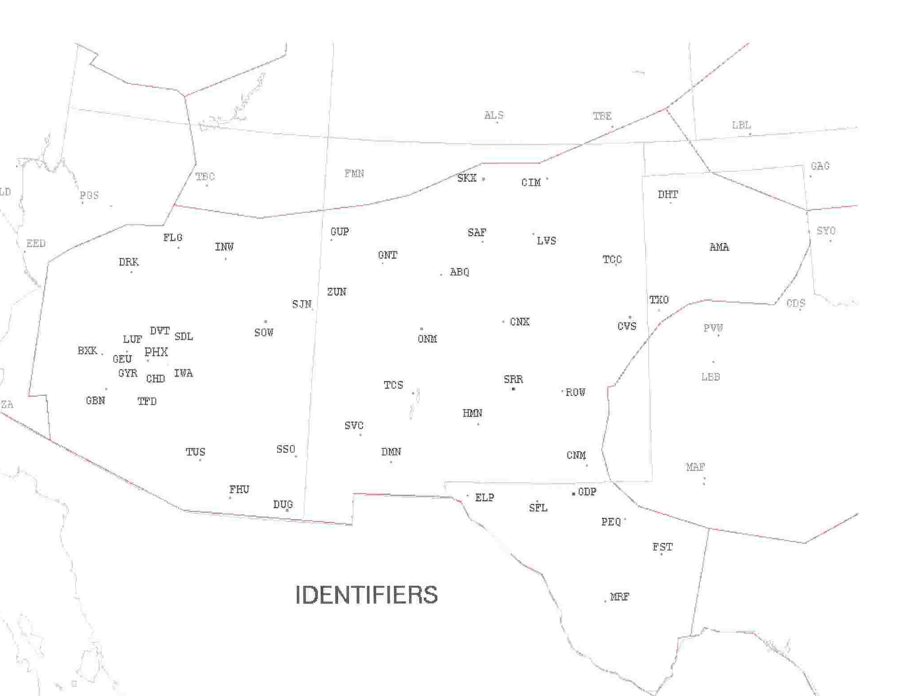
  - ZAB ARTCC Identifiers

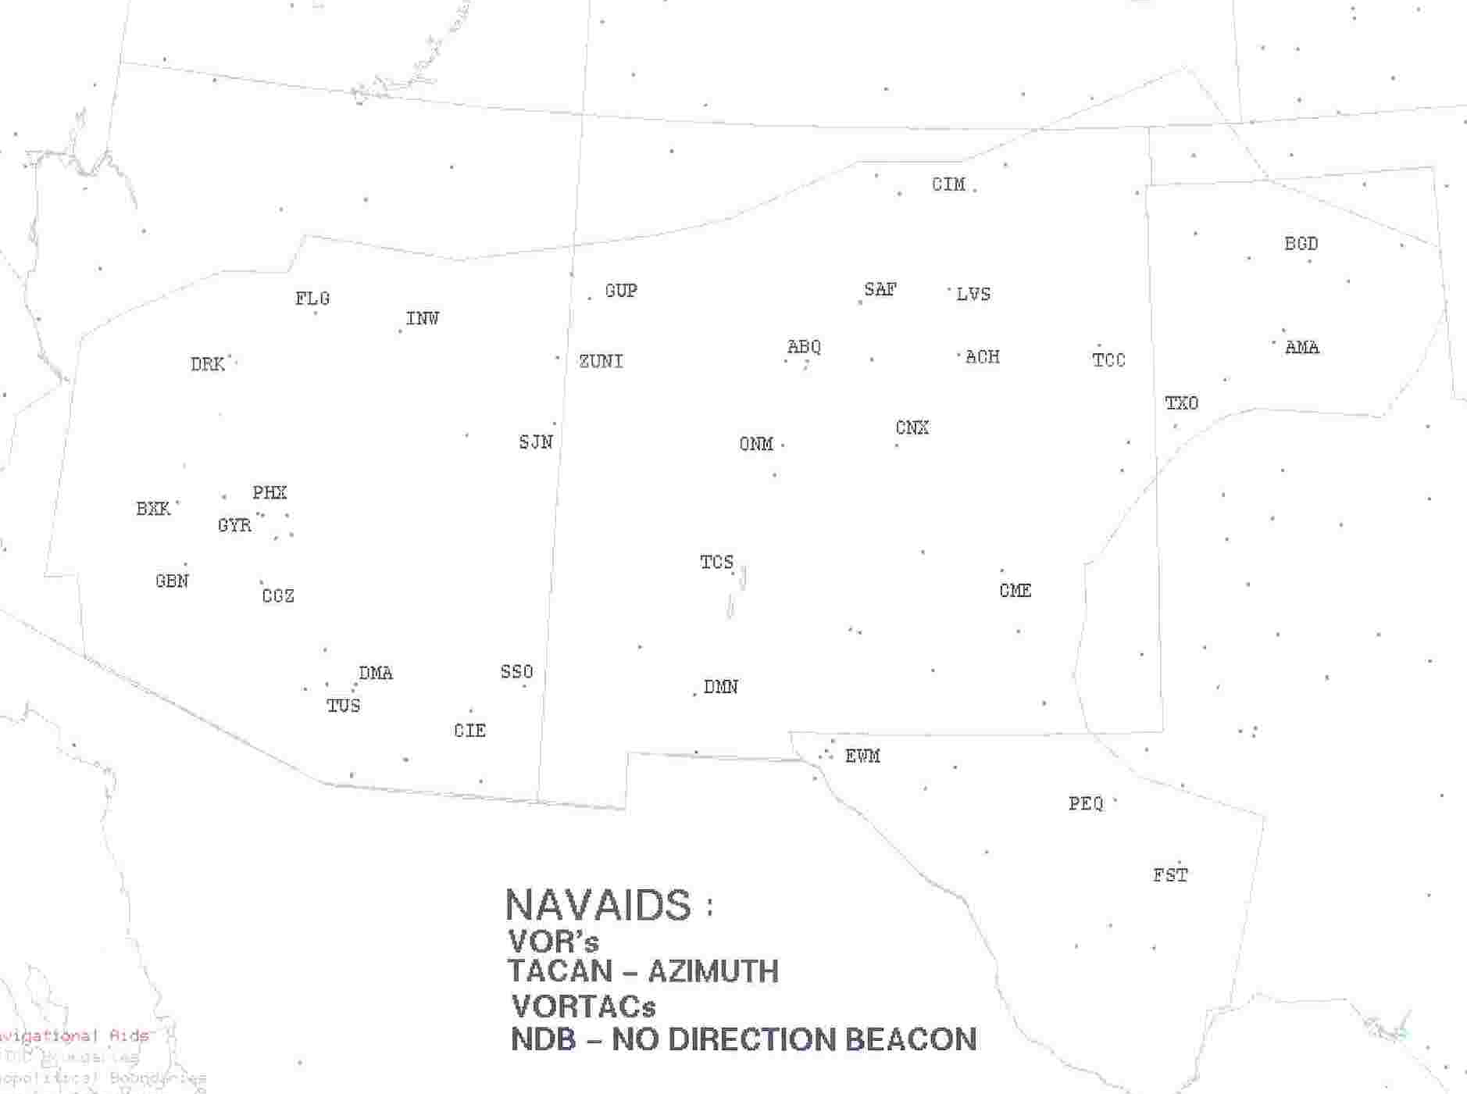

ARTCC Facility Structure
  - TMU Positions:
    - __PHX and metro area airports _____________________________________
Weather Impacts ___See specialty weather impacts below.__________________
    - __Handles all other traffic for airports across the national airspace._________
Weather Impacts ____ See specialty weather impacts below.________________
    - ___Alerts, Restrictions__________________________________
Weather Impacts ______ See specialty weather impacts below. ___________
    - __Weather Coordinator _______________________________
Weather Impacts _____ See specialty weather impacts below._________

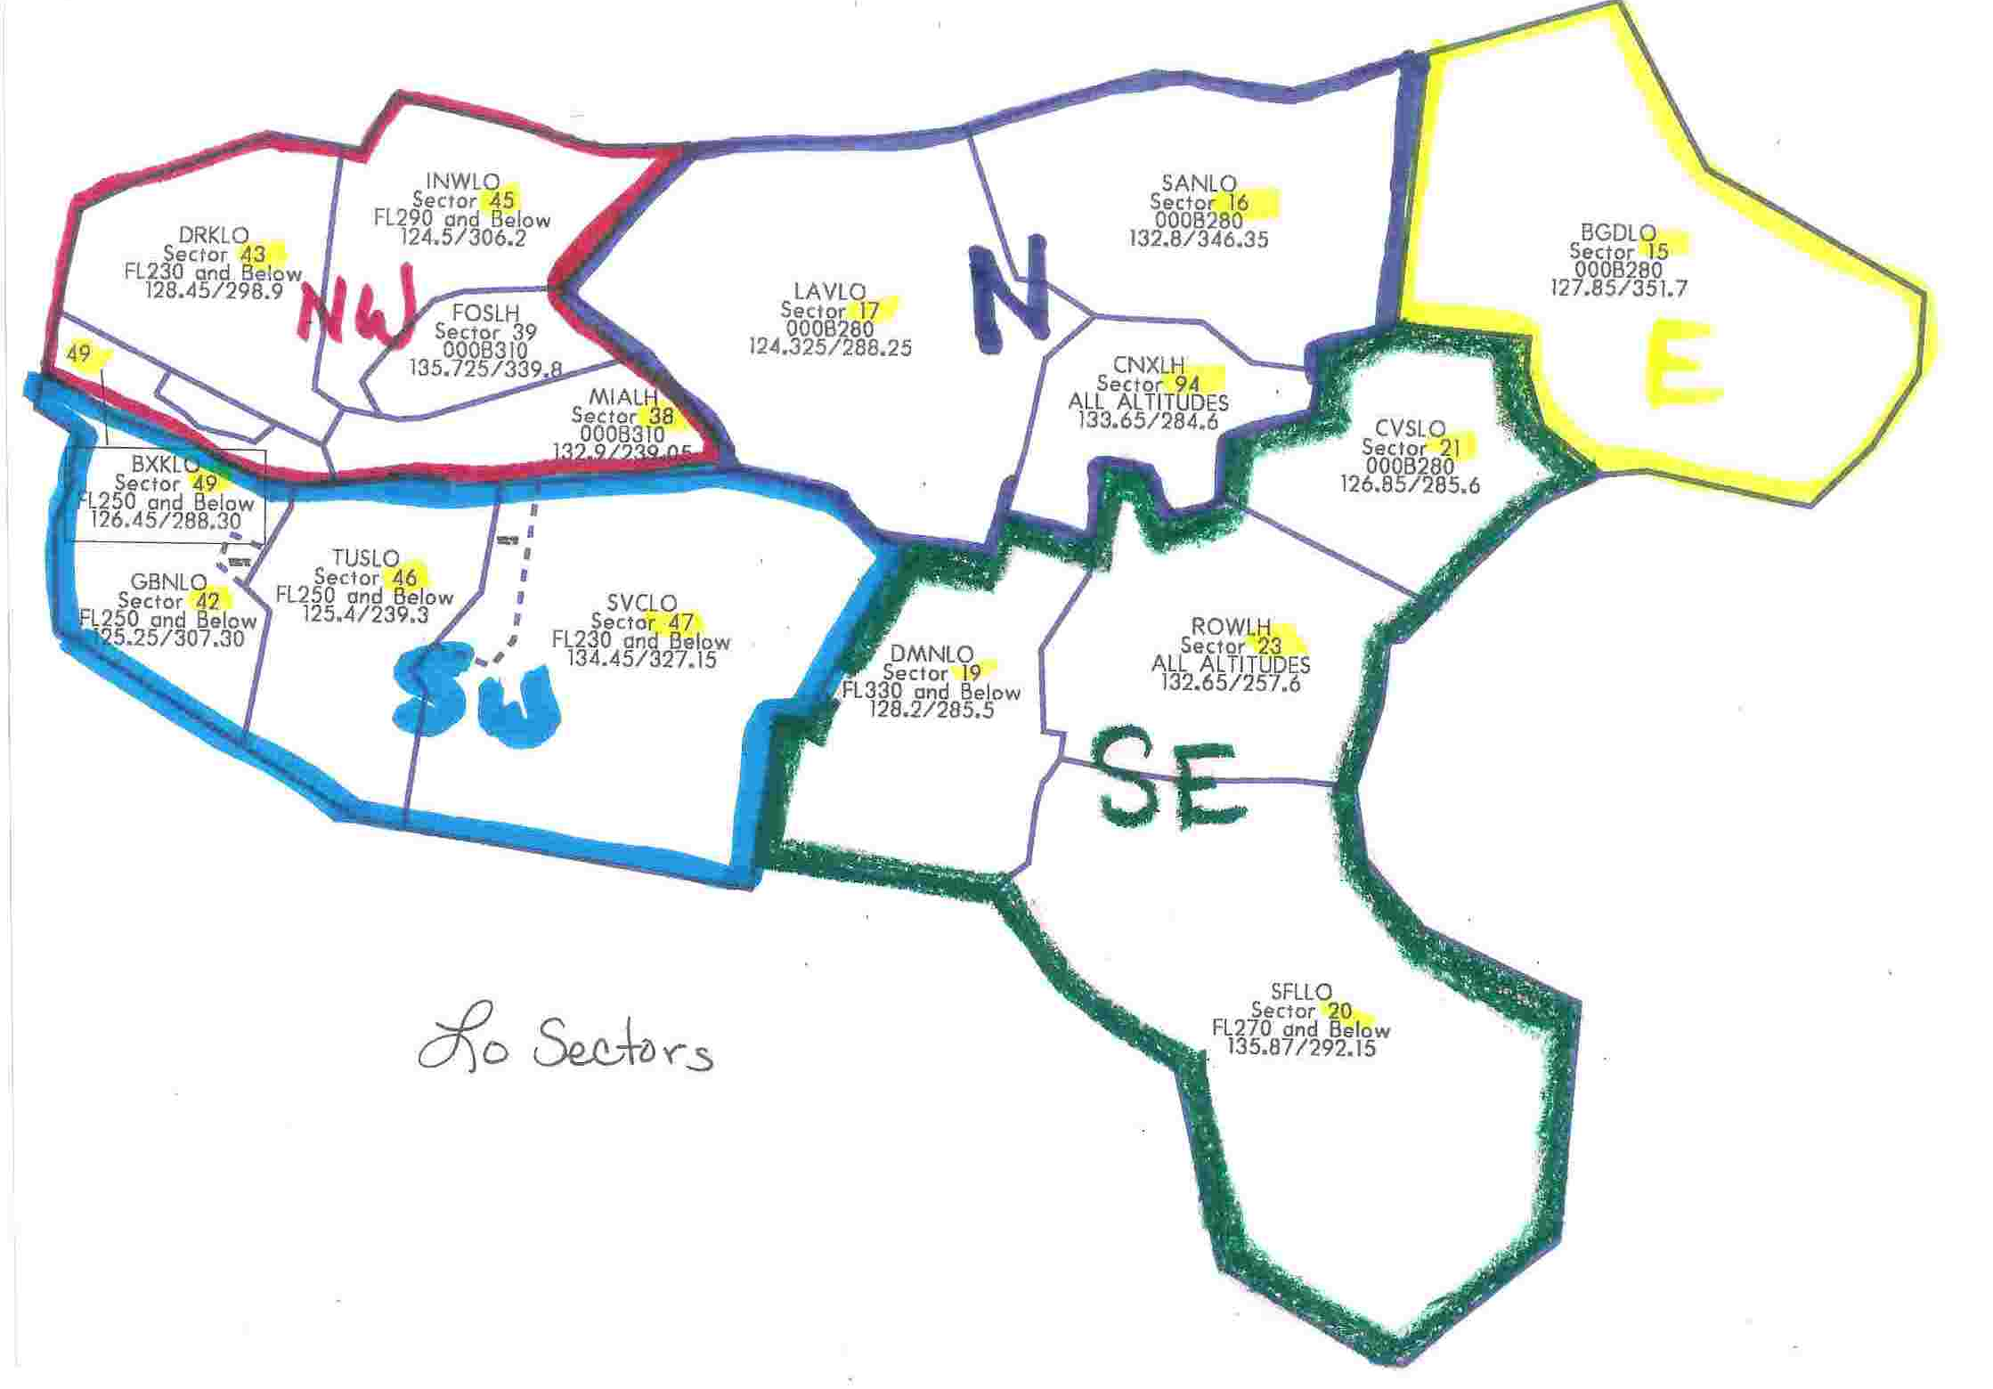

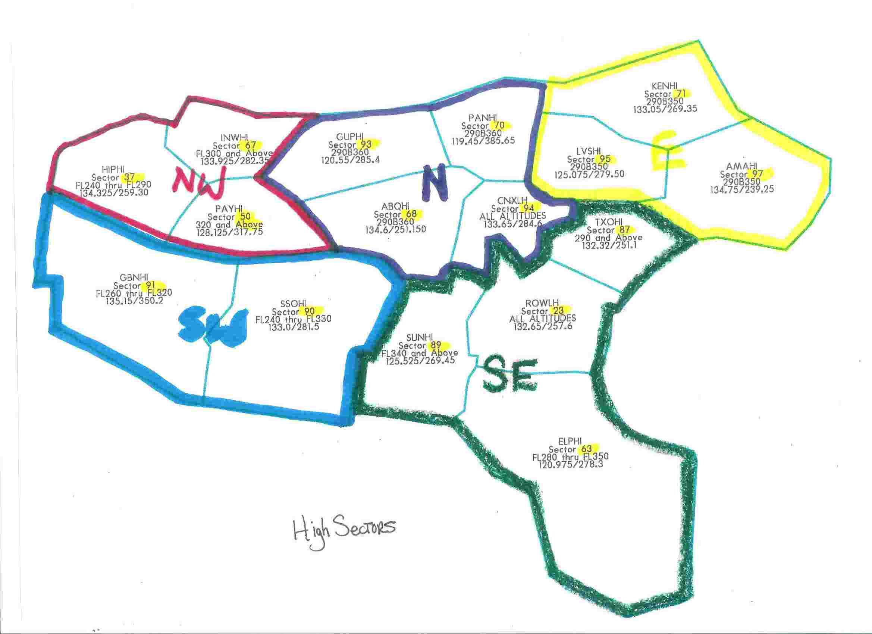

  - Area 1 Sectors: General Area _____Northwest Specialty __________________
Operations Manager/Area Supervisor ____Carol Latham___________________
    - Ultra High# __92___________________________________
    - High# __37, 38, 39, 67_________________________________________
    - Low# ______38, 39, 43, 45 ___________________________________
    - En Route Weather Impacts __Mtn obscn, also see notes below._________
  - Area 2 Sectors: General Area ______North Specialty________________
Operations Manager/Area Supervisor ____Chuck Oliver / Mark Spaulding______
    - Ultra High# _______79________________________________________
    - High# _______93, 70, 68, 94_____________________________
    - Low# _____16, 17, 94_________________________________________
    - En Route Weather Impacts ___Mtn wave, mtn obscn, also see notes below.____
  - Area 3 Sectors: General Area ______East Specialty_________________
Operations Manager/Area Supervisor __Larry Rolls________________
    - Ultra High# _____72, 96, 98 ______________________________
    - High# ______71, 95, 97________________________
    - Low# _____15___________________________________________________
    - En Route Weather Impacts ____Mtn wave, mtn obscn, also see notes below. _
  - Area 4 Sectors: General Area ______Southeast Specialty______________
Operations Manager/Area Supervisor ____Carol Latham / Larry Rolls__________
i. Ultra High# _____78, 89____________________________________
ii. High# _____19, 23, 87, 63_____________________
iii. Low# ___19, 20, 23_____________
- En Route Weather Impacts ______See notes below.__________________
  - Area 5 Sectors: General Area ______Southwest Specialty___________________
Operations Manager/Area Supervisor ______Chuck Oliver___________________
    - Ultra High# ___65, 80____________________
    - High# _____91, 90______________________
    - Low# _____42, 49, 46, 47_____________________
    - En Route Weather Impacts _____PHX impacts, also see below.__________

Specialty Weather Impacts:
Note: Thunderstorms most numerous during summer season impacting all areas. Turbulence and icing affect all areas mainly September through April.
PHX arrivals and departures are more critical and affected by all weather elements. Mainly during winter season haze/fog is a major impact the day(s) after significant rainfall. Ceilings 5000 ft. and below as well as slant range visibilities and restrictions lower landing acceptance rates.

  - TRACONs and Phone #s within ARTCC _________________________________
    - ___PHX 602-273-3718________________________________
    - ___ABQ EXT. 4935_______________________________________
    - ___ELP 915-774-9407_______________________________________
    - ___AMA 806-335-4002___________________________________
    - ___TUS 520-670-6213__________________________________
  - FAA Towers and Phone #s within ARTCC ______________________________
    - ______ABQ 505-856-4924______________________________
    - ______AMA 806-335-4003_____________________________________
    - ______ELP 915-774-9408____________________________________
    - ______FLG 928-774-7560______________________________________
    - ______IWA 480-988-7675____________________________________

Hub/Pacing Airport
  - ______PHX___(three east–west runways).________

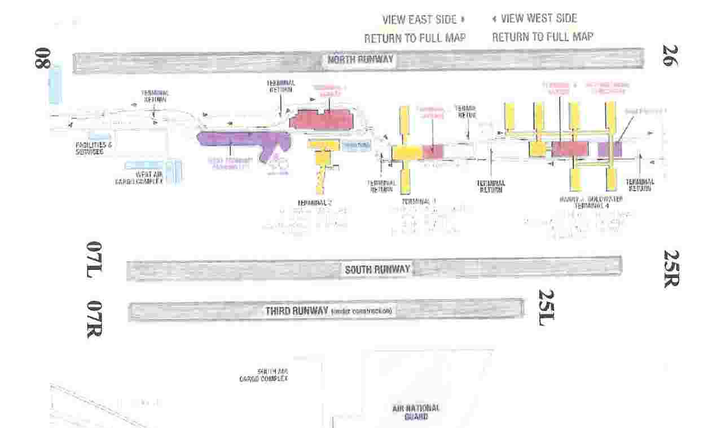
    - Time of Daily Pushes (i.e., aviation “rush hour”)
      - Morning ______16Z___________________________________________
      - Afternoon/Evening _____01Z____________________________________
      - Other _____5 mini pushes throughout the day (mainly from L.A.)________
    - Runways _____Three runways at PHX____08 and 07L & R_______________

          - Arrivals: ____Coyot (from NW), Arlin (from West), Sunss (from SSE), Buntr (from NE). Departures: Silow, St.Johns, Maxxo, Stanfield, Mobie, Buckeye, Chily…..see below figures…__________________________
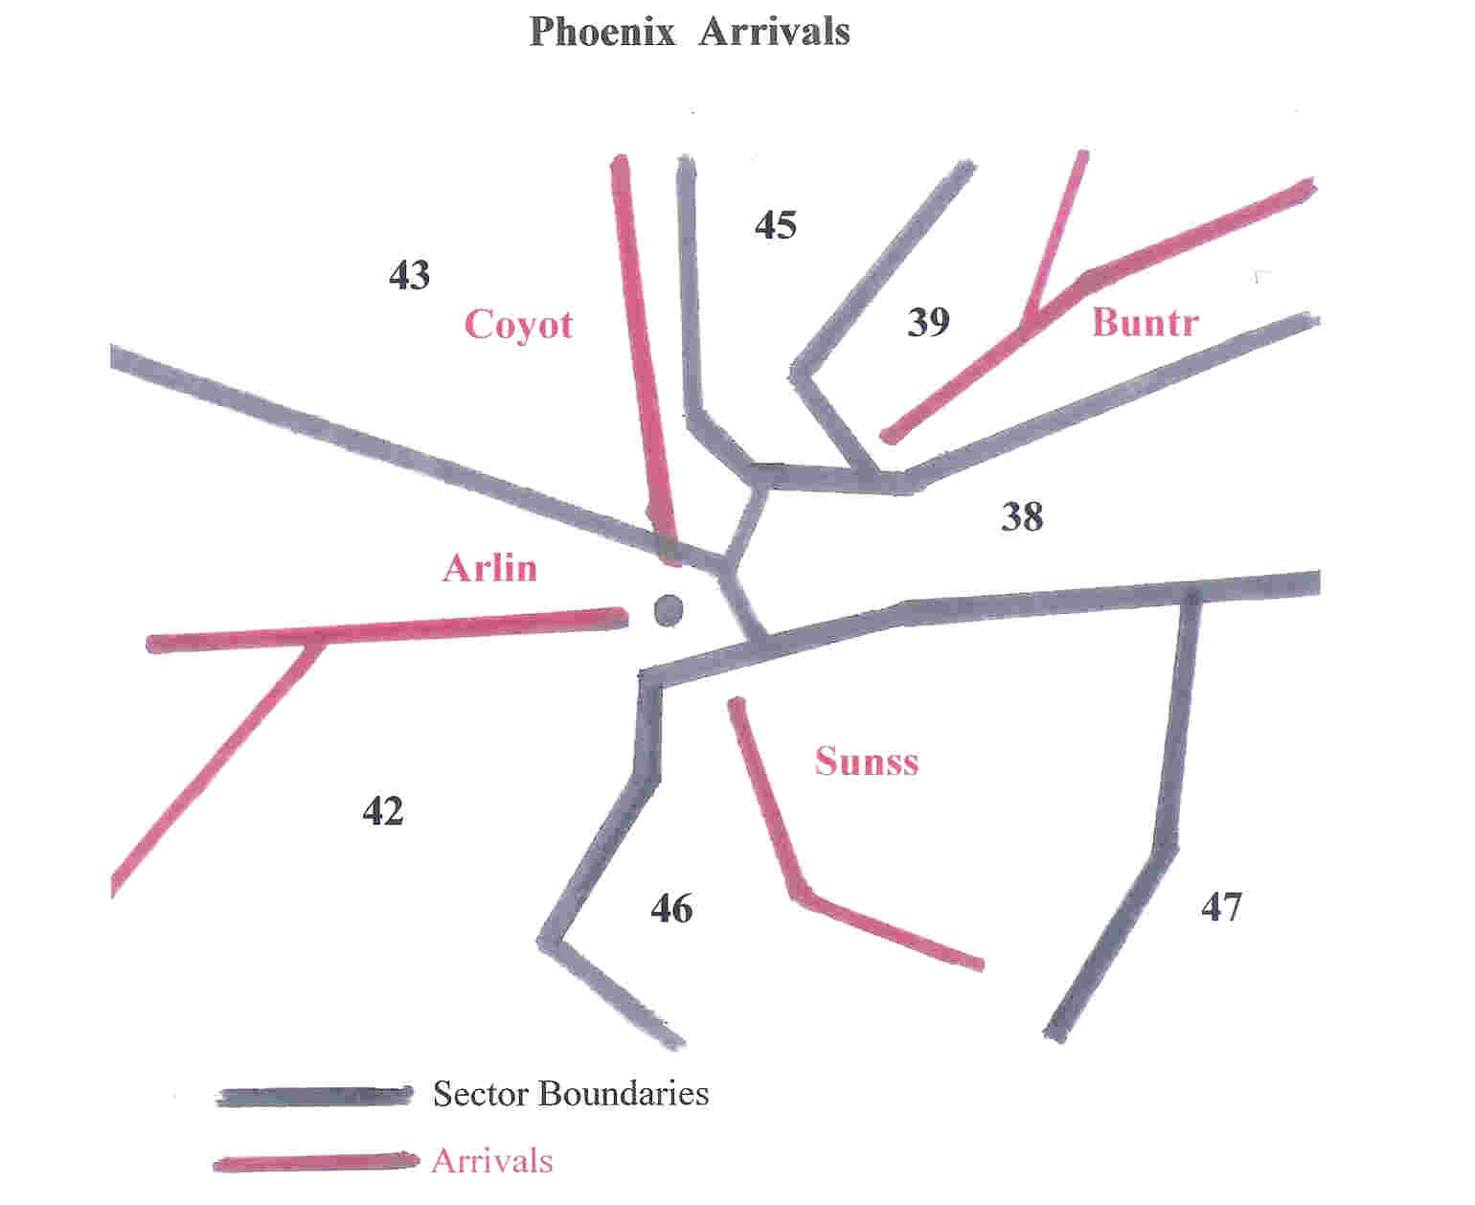
          - Minimums ___400ft and ½ mile on RR07, 800 and 2 ½ on RR08___
          - Limiting Issues ____5,000ft clouds on approach, &/or limiting slant-range visibilities will force instrument approaches, which lowers the acceptance rate.

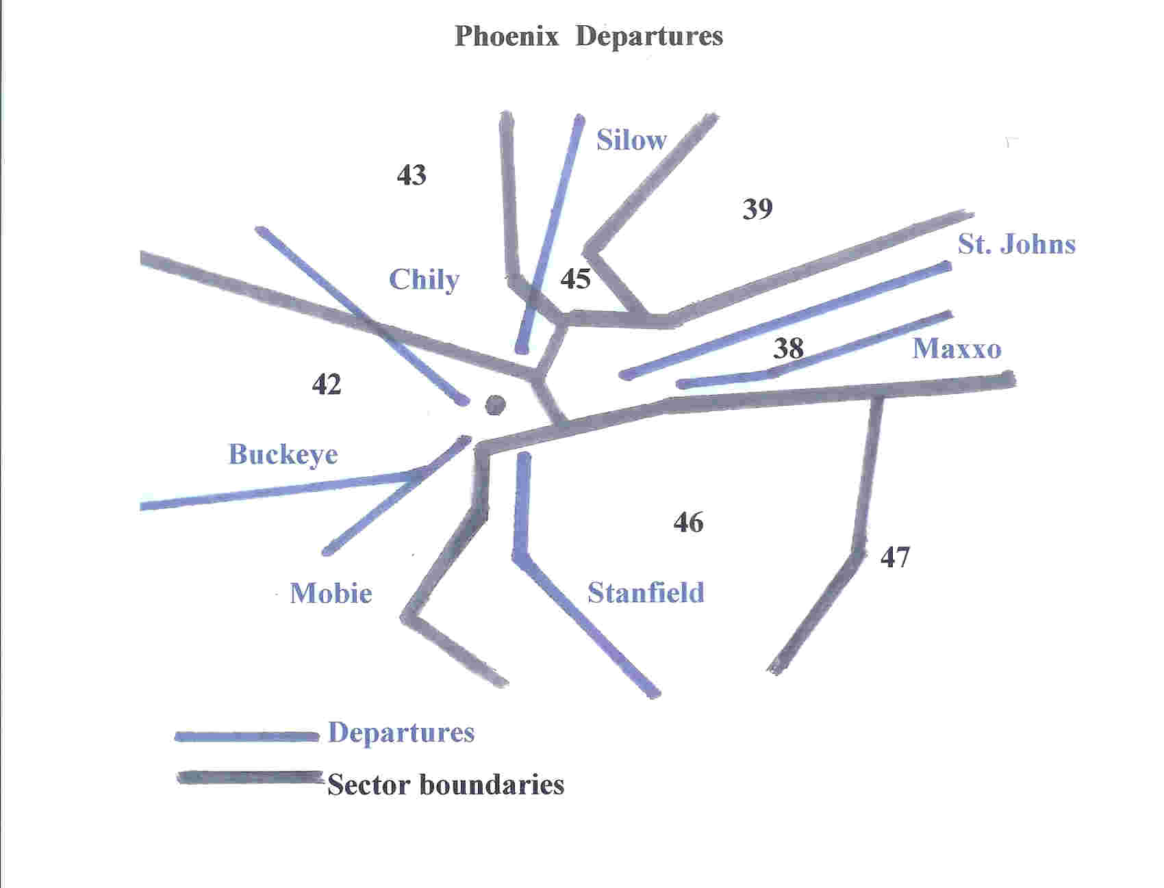

    - Significant Weather
      - TS _____Over approaches or departures will cause TMU major problems. Also, thunderstorms over the Mogollon Rim (where aircraft are descending toward PHX) will cause diversions and increase TMU/Controller workload._
      - Visibility ____PHX approach/landing vis < or = 3 NM __________
      - Ceilings _____5,000 Ft or less on approach can lower landing acceptance rates.________________________________________________
      - Weather ____Haze, cross winds >25 kts, severe turb, icing, _________________________________________________
      - Other ___Security concerns_____________________________
Phoenix Climatology: 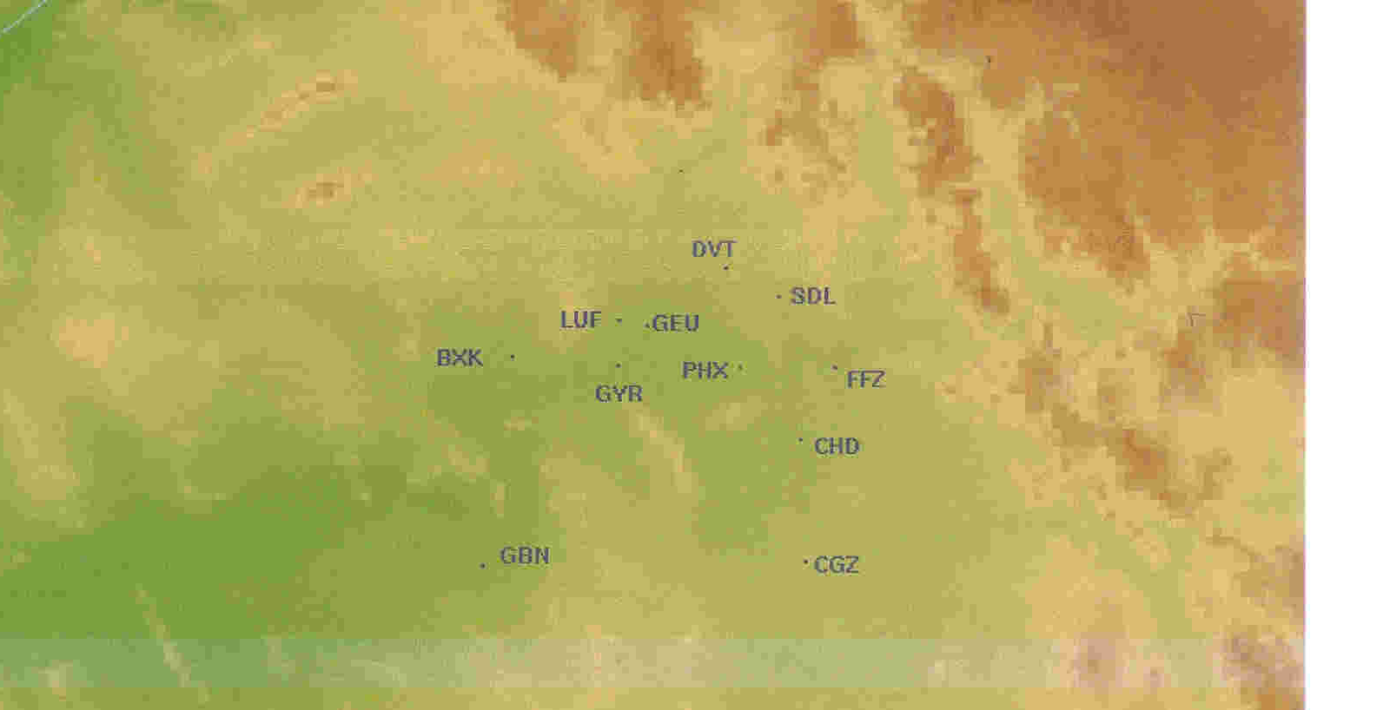
Phoenix is located in about the center of the Salt River Valley (see picture above).
This broad, oval-shaped nearly flat plain has the Salt River Mountains six miles to the south at 2600 feet MSL. The Phoenix Mountains 8 miles to the north rise 2600 feet MSL. The Camelback Mountain lies 6 miles to the north-northeast to 2700 feet MSL. Eighteen miles to the southwest lay the Sierra Estrella Mountains at 4500 feet MSL.
The first “rainfall” season occurs during the months March through November. But Phoenix is a generally hot and dry (see temperature graph below) desert area with monsoonal moisture during the thunderstorm season of July and August. There are often local, strong, gusty winds with considerable blowing dust with these thunderstorms, though seldom before the evening hours. See precipitation graph below.

See Phoenix Climate web site for more information:
http://geography .asu.edu/cerveny/wxpart1.htm

PHOENIX WSFO AP, ARIZONA

POR - Monthly Average Total Precipitation
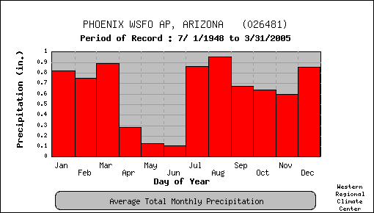
- Average precipitation recorded for the month.

PHOENIX WSFO AP, ARIZONA

POR - Daily Temperature Averages and Extremes
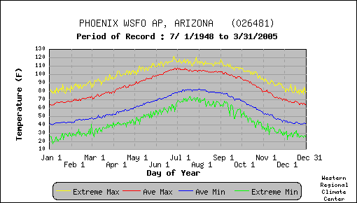
- Extreme Max. is the maximum of all daily maximum temperatures recorded for the day of the year.
- Ave. Max. is the average of all daily maximum temperatures recorded for the day of the year.
- Ave. Min. is the average of all daily minimum temperatures recorded for the day of the year.
- Extreme Min. is the minimum of all daily minimum temperatures recorded for the day of the year.

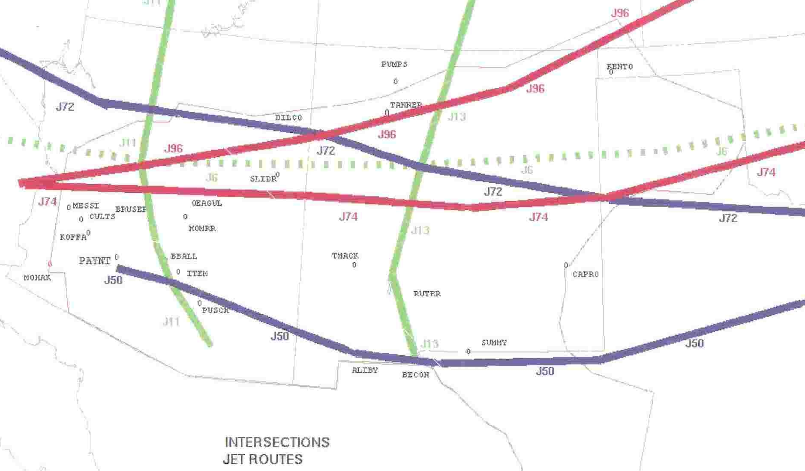

FAA Playbook Operations and CCFP
  - Support to Strategic Plan of Operations Telcon
    - Participants ____TMU’s and CFCF________________________________
    - Telcon Schedule ___Every other hour (with our CCFP the hours in between)._____________________________________________
    - Weather Requirements ____CCFP maps________________________
  - Weather Impacts to Internal Airports
    - __TSTMS_________________________________
  - Weather Impacts to Outer-Tier Airports requiring playbooks.
    - ___TSTMS.
    - Below are the four most used playbooks for ZAB airspace:
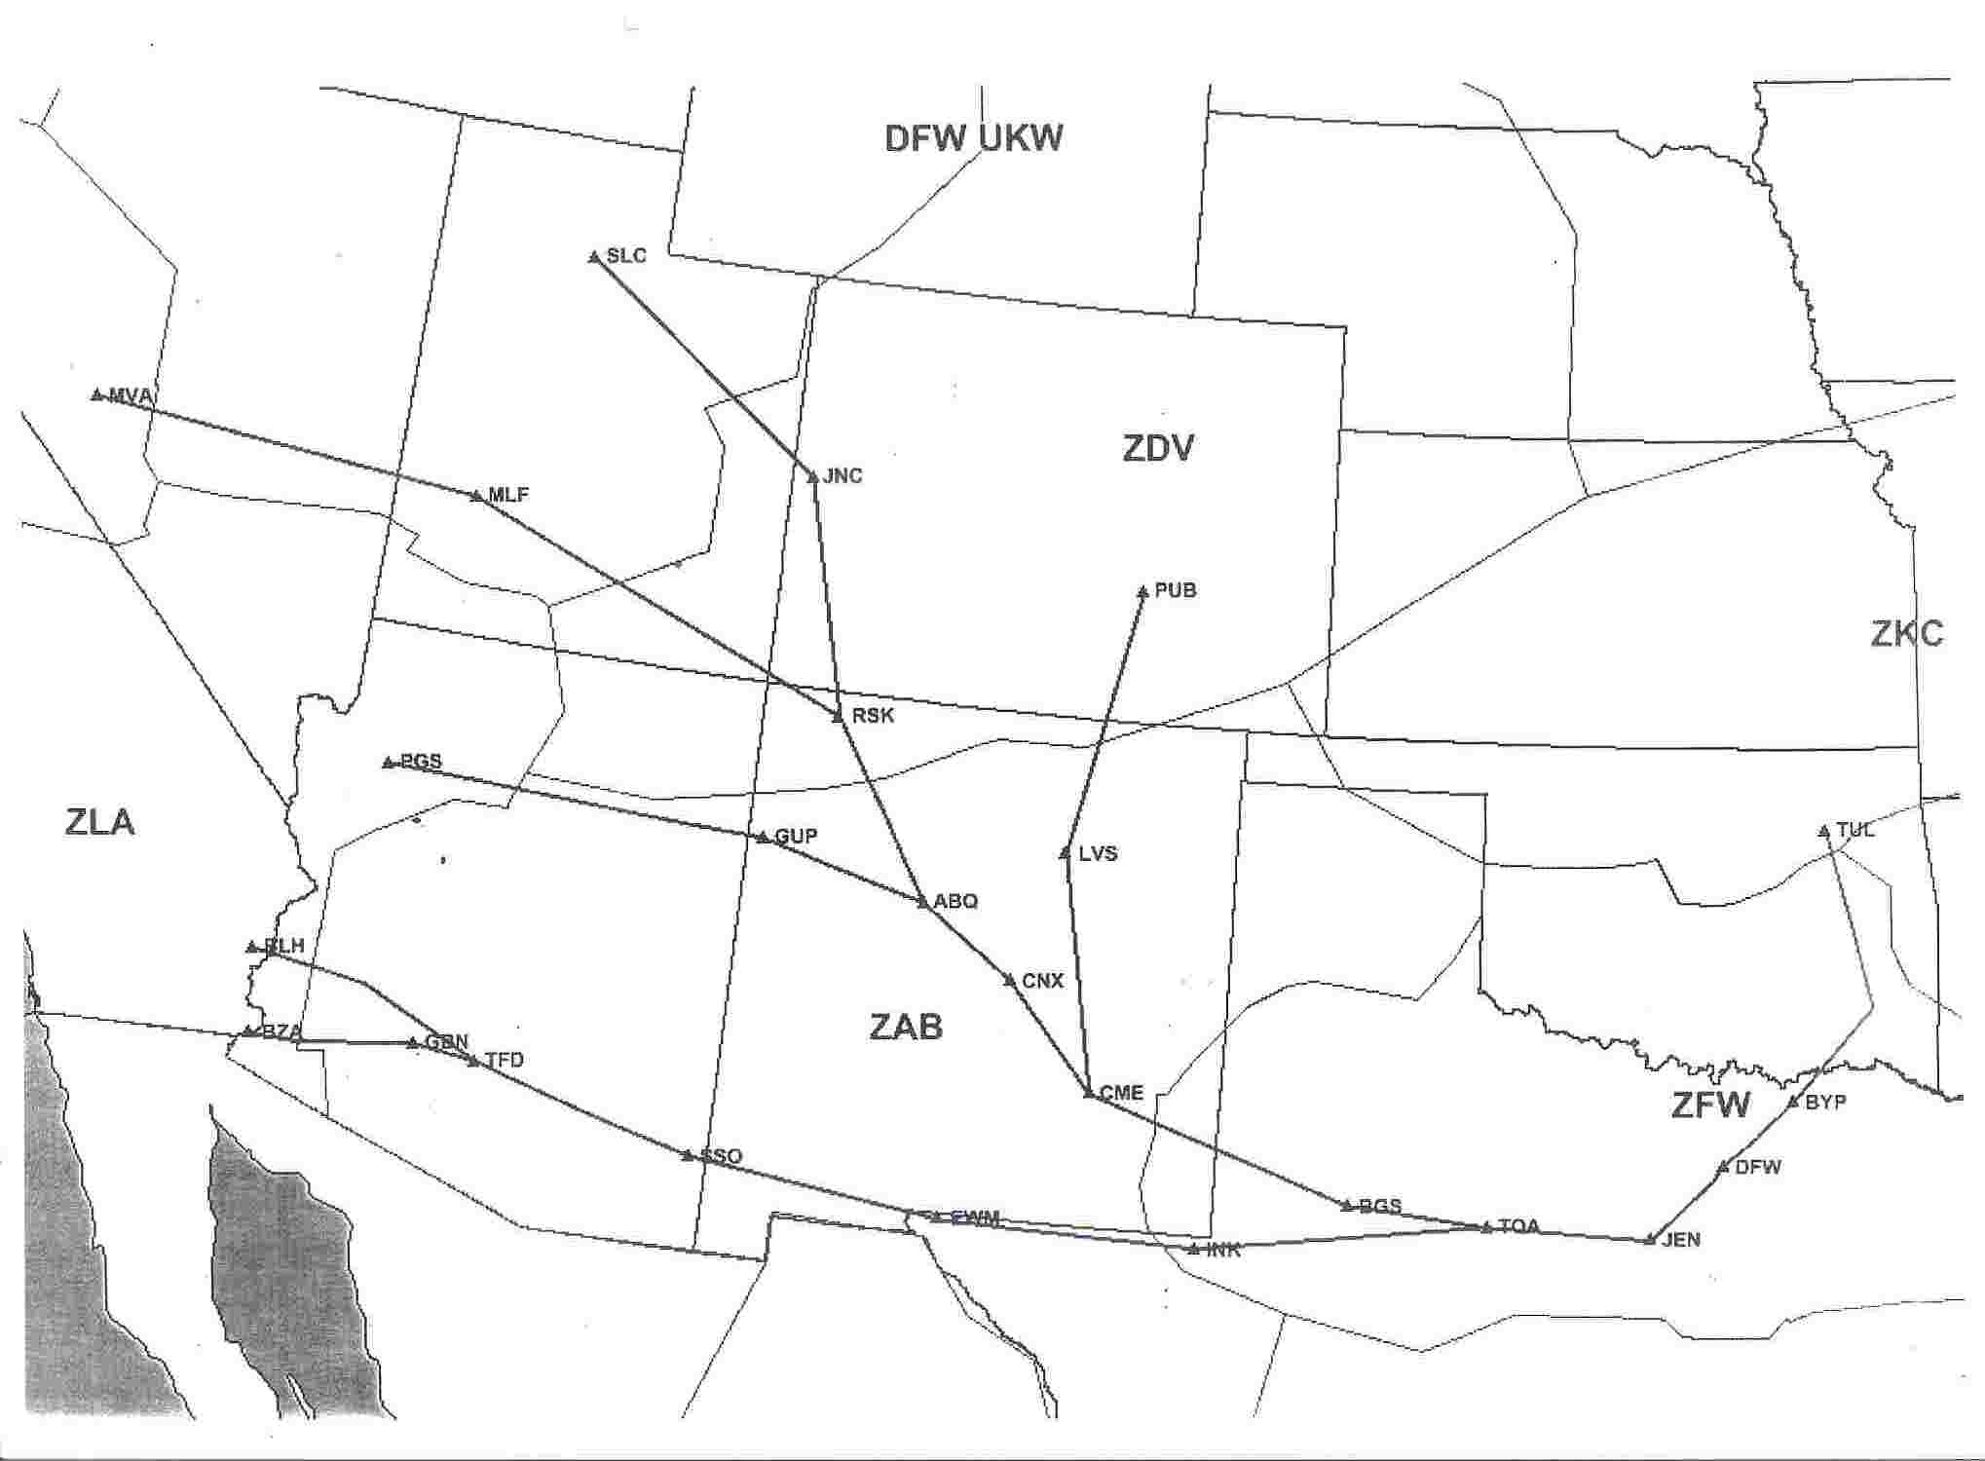
The Bowie Playbook (UKW) is enacted when significant thunderstorms are occurring over the TX panhandle and into Oklahoma, and the aircraft are scheduled to land at DFW.

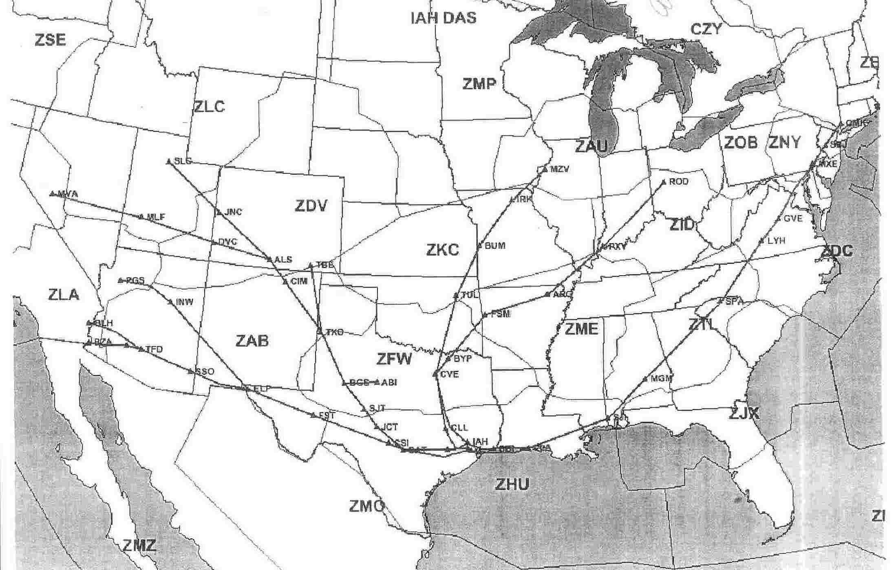
The Hoagi (IAH), or Dasetta (DAS) playbook is enacted when significant thunderstorms are also occurring over the TX panhandle into Oklahoma, and aircraft are scheduled to land in Houston.

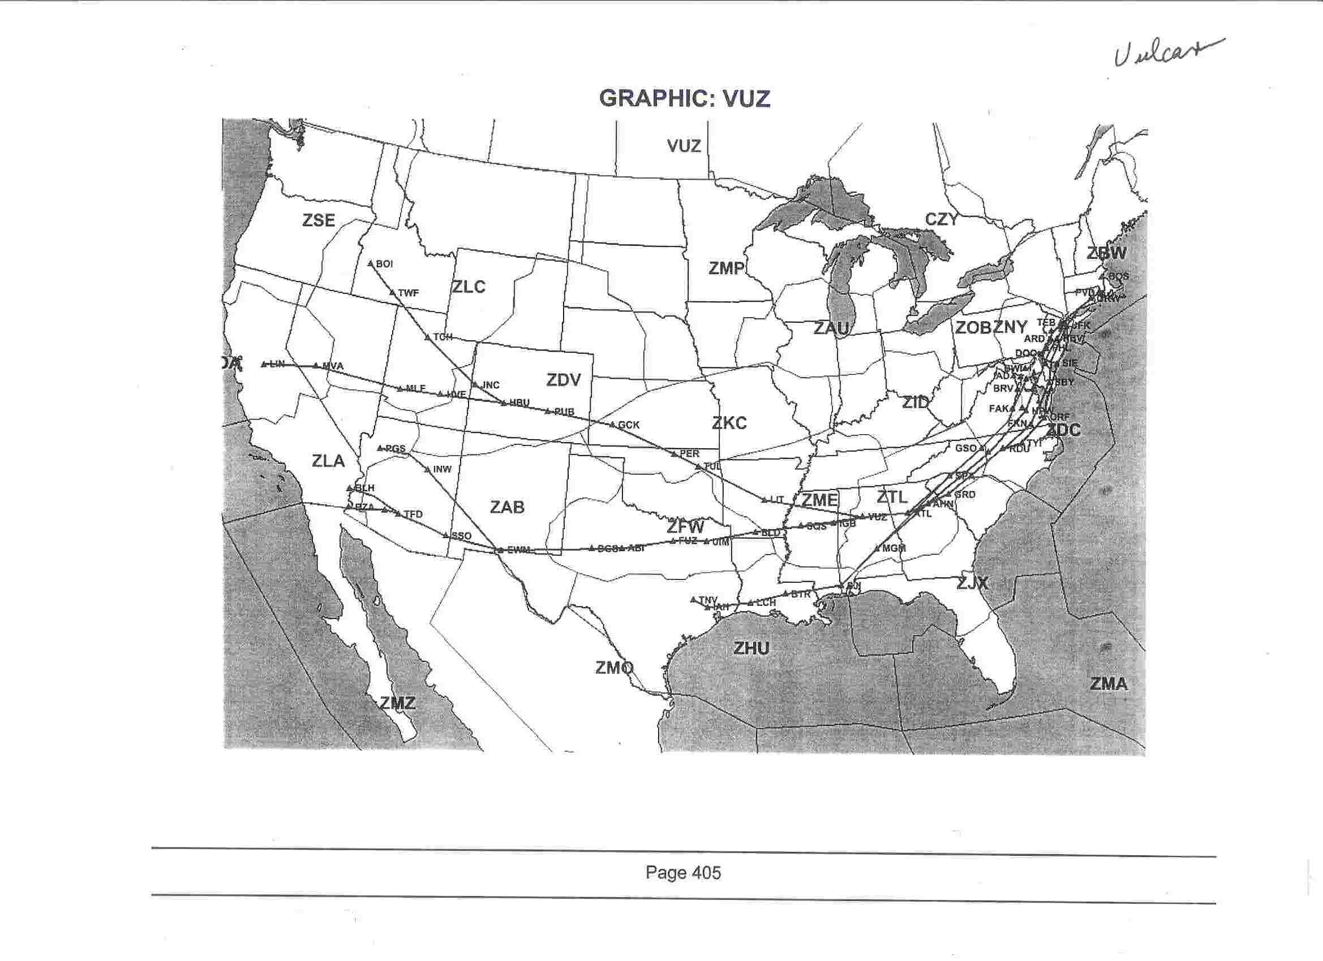
The Vulcan Playbook (VUZ) is enacted when thunderstorms are significant and have formed over the Midwest and extend into Kansas. The aircraft are scheduled to land on the east coast.

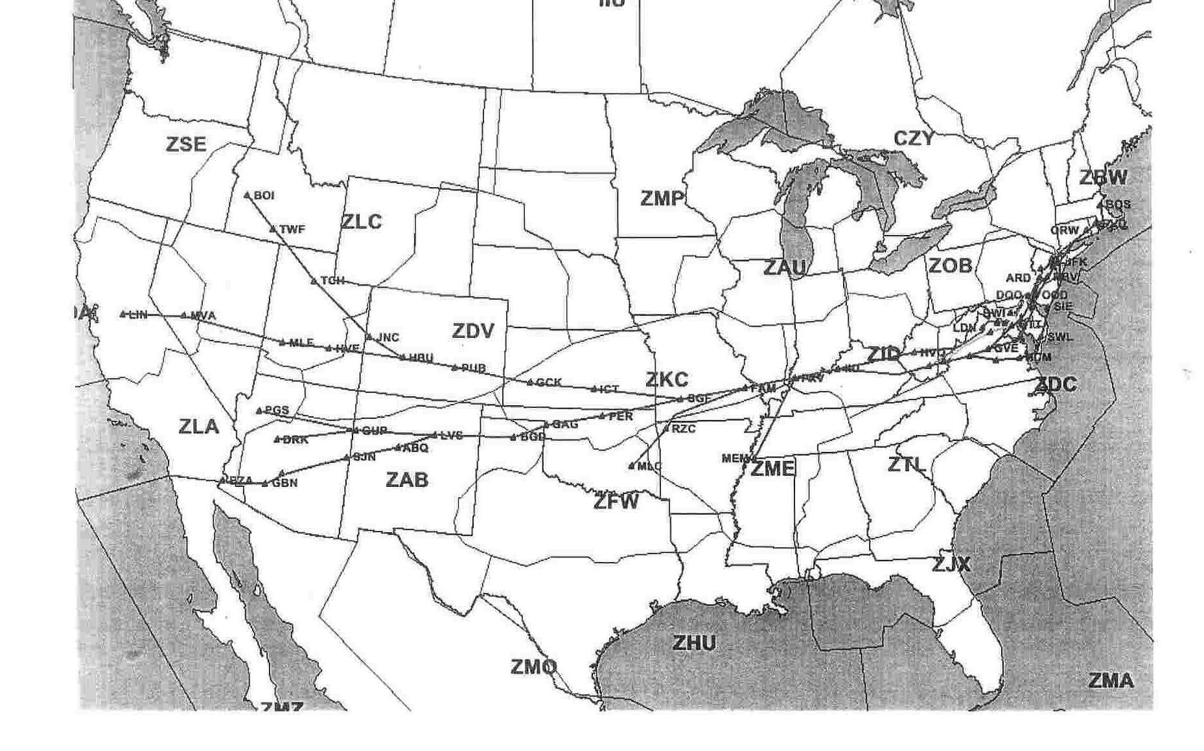
The Louisville Playbook (IIU) is enacted when significant thunderstorms are occurring over the Dakotas, Nebraska, Minnesota, and Iowa area. Major aircraft are bound for the east coast.

  - Airway Closers
    - _____TSTMS, SVR TURB, MOD-SVR ICING, SMOKE, VOLCANIC ASH
can cause airway closures.

Special ARTCC Requirements
  - Quality Control Office Weather Support Requirements for
    - Operational Errors
      - ____METAR’s, TAF’s, GOES, NEXRAD, Area Forecasts (FA), PIREPS, SIGMETS, CONVECTIVE SIGMETS, AIRMETS, CWA’s, and other pertinent info._________________
    - Aircraft Accidents (fatal and non-fatal)
      - _____METAR’s, TAF’s, GOES, NEXRAD, Area Forecasts (FA), PIREPS, SIGMETS, CONVECTIVE SIGMETS, AIRMETS, CWA’s, and other pertinent info._________________
  - Routine Briefings to ARTCC and other FAA Facilities
    - ARTCC Verbal Briefings
      - Standup/Management Briefing Times
- ___07:30 AM______________________________________
- ___15:30 PM_______________________________________
      - Locally Required Briefing Content
- ____JET, TURB, ICG, TSTMS, LOW ALTIMITERS, IFR, PHX ARRIVAL WINDS, PHX TERMINAL WX, NUMEROUS HUB TERMINAL FORECASTS, CCFP FORECASTS, MTN OBSCN, OTHER SIGNIFICANT WEATHER THAT EFFECTS SAFETY OR SMOOTH AND EFFICIENT FLOW OF AIRCRAFT._____________

*** END ***

